**Title**

**Gender and Age Detection**

**Group members:**

Zainab Durrani (55980)

Zainab Kamran (57429)

Wania Zulfiqar (57717)

Israr Nadeem (55795)

**Introduction:**

Welcome to the Gender and Age Detection project using Python and Open CV! In this exciting venture, we're tapping into the power of technology to figure out a person's age and gender from just a picture of their face. Picture this as a virtual detective that can make educated guesses about someone just by looking at them.

**Tool kit:**

Our toolkit for this adventure includes Python, a versatile programming language, and Open CV, a cool library for computer vision. But the real superhero here is deep learning – a fancy way of saying we're teaching the computer to learn from examples.

**Code editor:**

In our project, we have chosen PyCharm as our preferred code editor. PyCharm, a robust integrated development environment for Python, provides us with a seamless and efficient coding experience. We added a smart tool called a Convolutional Neural Network (CNN) to our project. This helps us better understand and analyse details in facial pictures, making our gender and age detection more accurate.

**Goal:**

To create a smart system that can look at a face in a photo and tell you if it's a man or woman and make a pretty good guess about their age. It's like magic, but with a touch of technology!

**Installed Libraries:**

In our project we are going to use these three libraries:

* OPEN CV
* MATH
* ARGPARSE

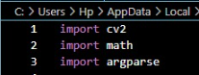

**Functions:**

* **Open CV** (Open Source Computer Vision Library) is a powerful library for computer vision and image processing tasks we're using it because it helps us handle images and videos efficiently. In our project, it's the go-to tool for working with facial images – from reading them to processing and analysing.
* The **math** module is a part of Python's standard library and provides mathematical functions we're using it because We need mathematical operations in our project, like rounding off numbers or performing calculations related to age detection.
* The **argparse** module is a standard Python library for parsing command-line arguments. we're using it because it allows us to take input from the user when running our Python script. In our project, it could be used, for example, to specify the file path of the image we want to analyse without changing the code every time.

**Piece of code:**

This is our non-functional piece of code:

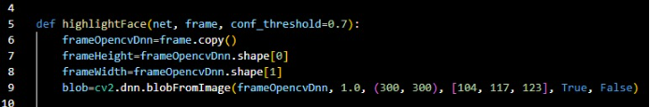

**Explanation:**

This Python function, highlightFace, is designed for face detection using a pre-trained neural network model (net). It takes an input image (frame), creates a copy, retrieves its dimensions, and converts it into a suitable format (blob) for the neural network. The conf_threshold parameter sets a confidence threshold for considering a detected face.